

**Project Status Report**



**Project Name:** Internet of Things Solution for Asia Pacific College’s Facility Management System

**Department:** SoCIT

**Focus Area:** Internet of Things

**Product/Process:** The project is intended to automate the operation of facilities used with rooms for scheduled classes.



**Prepared By:**

|  |  |
| --- | --- |
| **Document Owner(s)** | **Project/Organization Role** |
| John Matthew B. Fonacier | Project Manager & Documenter |
| Ivan Jasper U. Evangelista | System Analyst |
| Marco Theo A. Butalid | System Analyst & Developer |
| Luis Ginno Mabaquiao | System Analyst |

**Project Status Report Version Control**

|  |  |  |  |
| --- | --- | --- | --- |
| **Version** | **Date** | **Author** | **Change Description** |
| 1.0 | 6/19/18 | * John Matthew B. Fonacier | Document created |
| 1.1 | 6/20/18 | * Marco Theo A. Butalid * Ivan Jasper U. Evangelista * John Matthew B. Fonacier | * Event Table |
| 1.2 | 6/27/18 | * Marco Theo A. Butalid * Ivan Jasper U. Evangelista * John Matthew B. Fonacier | * Context Diagram * Data Flow Diagram – Level 0 * Data Flow Diagram – Level 1 |
| 1.3 | 7/4/2018 | * Marco Theo A. Butalid * Ivan Jasper U. Evangelista * John Matthew B. Fonacier * Luis Ginno Mabaquiao | * Object Diagram * Activity Diagram |
| 1.4 | 7/7/2018 | * Marco Theo A. Butalid | * First phase of prototype completed |
| 1.5 | 7/11/2018 | * Marco Theo A. Butalid * Ivan Jasper U. Evangelista * John Matthew B. Fonacier * Luis Ginno Mabaquiao | * Use Case * Use Case Full Description |
| 1.6 | 7/18/2018 | * Marco Theo A. Butalid * Ivan Jasper U. Evangelista * John Matthew B. Fonacier * Luis Ginno Mabaquiao | * Entity Relationship Diagram * Data Dictionary * Class Diagram * System Sequence Diagram |
| 1.7 | 7/18/2018 | * Ivan Jasper U. Evangelista | * Wireframes |

**TABLE OF CONTENTS**

Contents

1 PROJECT STATUS REPORT PURPOSE 4

2 PROJECT STATUS REPORT TEMPLATE 4

2.1 Project Status Report Details 4

2.2 Project Status Report Template 5

3 PROJECT STATUS REPORT APPROVALS 9

4 APPENDICES 10

4.1 Document Guidelines 10

4.1.1 Event Table 10

4.1.2 Context Diagram 12

4.1.3 Data Flow Diagram – Level 0 13

4.1.4 Data Flow Diagram – Level 1 14

4.1.5 Object Diagram 14

4.1.6 Activity Diagram 15

4.1.7 Use Case 16

4.1.8 Use Case Full Description 18

4.1.9 Entity Relationship Diagram 26

4.1.10 Data Dictionary 26

4.1.11 Class Diagram 31

4.1.12 System Sequence Diagram 32

4.1.13 Wireframe 35

4.2 Project Status Report Sections Omitted 37

# PROJECT STATUS REPORT PURPOSE

This document is intended to address different factors that are crucial to the project’s completion. It is the role of the Project Manager to communicate with its clients and advisors to be able to provide its members a clear picture of what the outcome of the project should be. The deliverables will provide:

* Context of significant progresses that are contributory to the project’s completion and its impact on the overall completion of the project
* Costing of the required materials to accomplish the project and different miscellaneous expenses contributing to the project
* Challenges faced by the members in completing the project and recommendations to such



# PROJECT STATUS REPORT TEMPLATE

## Project Status Report Details

The project is intended to automate the operation of facilities such as, air condition, lights and computers used with rooms for scheduled classes. The automation is done through the deployment of courses by the registrar’s office that is stored in Asia Pacific College’s Information System (APCIS). The project will then use these schedules as one of the processes to facilitate the room to help conserve Asia Pacific College’s (APC) energy consumption. Raspberry Pi 2 will be used to test the project until implementation.

The development of the project will last for two (2) months, not including the time spent gathering information about the different materials that will be used for the project. The materials used for the project was generously funded by Mr. Jojo Castillo, that includes the monitor, Raspberry Pi 3, keyboard, and mouse. So far, the only expense of the group was the purchasing of a 16gb micro SD card for the operating system of Raspberry Pi 3.

One of the issues faced by the group was the inconsistencies of information told by different offices. Which made it clear that there is a misunderstanding of different offices in terms of the reservation system. Thankfully, it is no longer part of the project. Originally, the reservation system was part of the project, mainly because the group thought that the reservation made by the reservees was real-time. However, it is not the case, the reservation system uses a database, but despite that, each reservation made is written on a piece of paper by the reservation clerk, that is forwarded to the Information Technology Resource Office (ITRO). ITRO then consolidates all the reservations made for a term audit. Meaning, the reservations made for a certain date, will not appear on the records until the end of the term. Making it unusable to the project the group is working on, unless otherwise the reservations made were a term in advance.

To fully utilize the use of this project, the group recommends that the reservations made are to be recorded and displayed in APCIS at the time it was reserved, for this project to make use of such. As not all operation of classrooms is made through class schedules.

## Project Status Report Template

|  |  |  |
| --- | --- | --- |
| Internet of Things Solution for Asia Pacific College’s Facility Management System | | |
| Prepared By:  Marco Theo A. Butalid,  Ivan Jasper U. Evangelista, John Matthew B. Fonacier, Luis Ginno Mabaquiao | Date:  7/4/2018 | Reporting Period:  6/20/2018 to 9/5/2018 |
| Project Overall Status:  The project’s client and advisor is the Technical Service Executive Director of Information Technology Resource Office (ITRO). The idea of the project is to automate the operation of the facilities using the schedules provided by the registrar that is stored in APCIS. The schedule will be used as a basis to turn on and off the facilities, namely, lights, air conditioner and/or computer. It is expected that with this implementation of such, the overall expense allocated for the operation of classroom will be lessen. The group will create the prototype for two (2) months using a microcontroller Raspberry Pi 3, using Raspbian Jessie. Different modules will also be used depending on the room type and the facilities behind it. The group is expected to accomplish the internal processes necessary to implement the IoT device, specifically:   * The adherence of the device to control the facility based on the class schedule only * Conditions to operate the facilities are met | | |
| Project Summary:  The project will make use of the class schedules provided by the registrar’s office that is stored in APCIS that will be used by the microcontroller to operate the facilities inside a room. Raspbian Jessie will serve as the backbone of the microcontroller, it is a Debian-based computer operating system for Raspberry Pi. The class schedules are deployed to the microcontroller’s database server that is MySQL and Python is used to program. Ideally, the deployment of the database in the microcontroller isn’t necessary, instead what will happen is the Raspberry Pi will serve as a client to the server hosting the database. That way, if ever there are changes in schedule, it will immediately reflect on the client’s side without having to redeploy the database again. On the Raspberry Pi 3, different modules will be connected specific for each type of room. The movement of the modules will be the output of the process. These modules are servo motors, and an IR transmitter, both will be used to operate the lights and air conditioner respectively. | | |
| **Milestone Deliverables performance reporting over last period**   |  |  |  |  | | --- | --- | --- | --- | | **Milestone Deliverables** | **Due Date** | **% Completed** | **Deliverable Status** | | Milestone 1 | | | | | * Completion of Event Table (See Appendix 4.1.1) | 6/20/2018 | 100% | Ahead of Schedule | | * Completion of Context Diagram (See Appendix 4.1.2) | 6/27/2018 | 100% | On Schedule | | * Completion of Data Flow Diagram – Level 0 (See Appendix 4.1.3) | 6/27/2018 | 100% | On Schedule | | * Completion of Data Flow Diagram – Level 1 (See Appendix 4.1.4) | 6/27/2018 | 100% | On Schedule | | * Completion of Object Diagram (See Appendix 4.1.5) | 7/4/2018 | 100% | On Schedule | | * Completion of Activity Diagram (See Appendix 4.1.6) | 7/4/2018 | 100% | Ahead of Schedule | | * Completion of Use Case (See Appendix 4.1.7) | 7/11/2018 | 100% | Ahead of Schedule | | * Completion of Use Case Full Description (See Appendix 4.1.8) | 7/11/2018 | 100% | Ahead of Schedule | | * Completion of Entity Relationship Diagram (See Appendix 4.1.9) | 7/18/2018 | 100% | Behind Schedule | | * Completion of Data Dictionary (See Appendix 4.1.10) | 7/18/2018 | 100% | Behind Schedule | | * Completion of Class Diagram (See Appendix (4.1.11) | 7/18/2018 | 100% | Behind Schedule | | * Completion of System Sequence Diagram (See Appendix 4.1.12) | 7/18/2018 | 100% | On Schedule | | * Completion of Wireframe (See Appendix 4.1.13) | 7/18/2018 | 100% | On Schedule | | Milestone 2 | | | | |  |  |  |  | |  |  |  |  | |  |  |  |  | | | |
| **Milestone Deliverables scheduled for completion over next period**   |  |  |  |  | | --- | --- | --- | --- | | **Milestone Deliverables** | **Due Date** | **% Completed** | **Deliverable Status** | | Milestone 1 | | | | |  |  |  |  | |  |  |  |  | |  |  |  |  | | Milestone 2 | | | | |  |  |  |  | |  |  |  |  | |  |  |  |  | | | |
| **Project impact of milestone success or failure for project remainder**   |  |  | | --- | --- | | [Replace this text with a description of milestone and potential scope changes.] | [Replace this text with a brief description of any changes to the project schedule required as a result of the amended milestone(s).] | | | |
| **Project** **Budget/Financial Status**   |  |  |  |  | | --- | --- | --- | --- | | **Budget Item** | **Planned Budget** | **Actual Cost** | **Variance/Explanation** | |  |  |  |  | |  |  |  |  | | | |
| **Project Risk Management Status**   |  |  |  |  |  | | --- | --- | --- | --- | --- | | **Risk and Description** | **Risk Chance** | **Risk Impact** | **Risk Priority** | **Change from Last Review** | | [Description of Risk] | [High/Medium/Low] | [High/Medium/Low] | [High/Medium/Low] | [Description] | | [Description of Risk] | [High/Medium/Low] | [High/Medium/Low] | [High/Medium/Low] | [Description] | | | |
| **Project Issue Management Status**   |  |  |  |  |  | | --- | --- | --- | --- | --- | | **Issue and Description** | **Project Impact** | **Target Due Date** | **Issue Status** | **Issue Resolution** | | [Description of Risk] | [High/Medium/Low] |  | [Open/Closed] | [Description] | | [Description of Risk] | [High/Medium/Low] |  | [Open/Closed] | [Description] | | | |
| **Project Recommendations**   |  | | --- | | [Replace this text with a brief statement for the Steering Committee, Project Sponsor, or Senior Manager to consider or endorse. Other questions to consider for review with key project stakeholders are:   * Will the project be completed on time and on budget?  * Will the project deliverables be completed within acceptable quality levels?  * Are scope change requests being managed successfully?  * Are project issues and risks being addressed successfully and mitigated?  * Are all customer concerns being addressed successfully?] | | | |
| **Objectives for Next Project Status Review**   |  | | --- | | [Replace this text with a brief outline of project expectations for key project stakeholders to consider for the next review.] | | | |
| **Related Project Information**   |  | | --- | | [Replace this text with an attachment or link to other relevant information that can be included with this project status report. Examples include:   * Budget Report Summary  * Issue Record Report  * Scope Change Report  * Project Work Plan  * Project Metrics/Statistics  * Quality Management Review.] | | | |



# PROJECT STATUS REPORT APPROVALS

**Prepared by** __________________________________

Project Manager

**Approved by** __________________________________

Project Advisor

__________________________________

Client Sponsor



# APPENDICES

## Document Guidelines

### Event Table

|  |  |  |  |  |  |
| --- | --- | --- | --- | --- | --- |
| Event | Trigger | Source | Use Case | Response | Destination |
| Provide Class Schedules. | Start of a New Term. | APCIS | Provide Updated Class Schedules. | Class Schedule Details. | FACILITY |
| Operation of facilities. | Class Schedules. | FACILITY | Checks Class Schedule Details. | Process Class Schedule Details. | APCIS |
| Professor reserves additional facility. | Professor reserved additional facility. | PROFESSOR | Reserve additional facility. | Record reservation. | APCIS |
| Activation of the facilities. | Based on Class Schedules. | APCIS | Activates the switch fuse and facilities in a room. | Activates the switch fuse for air conditioner and air conditioner itself 15 minutes before the time allocated and switch fuse for other facilities is turned on based on the time allocated. | FACILITY |
| Deactivates the air conditioner, lights and/or computers and switch fuse. | Turning off Facilities if:   * Professor is absent * Class is dismissed * Early dismissal * Class suspension   After the 5 minutes that the sensors had not detected any movement in a room. | APCIS | Deactivates facilities and switch fuse in a room. | Air conditioner, lights, and/or computers and switch fuse are deactivated. | FACILITY |
| Reactivating the facilities in a room. | Professor is late or the people using the room had to go out for more than 5 minutes. | APCIS | Reactivation of facilities. | Reactivates the switch fuse for all the facilities used in the room and facilities. | FACILITY |
| Facility sends feedback. | The time facilities are turned on and/or off. | FACILITY | Process feedback. | Provide reports based on the feedback. | APCIS |
| Professor reports faulty facility. | Professor reported faulty facility details. | PROFESSOR | Report facility details. | Sends report. | APCIS |

### Context Diagram

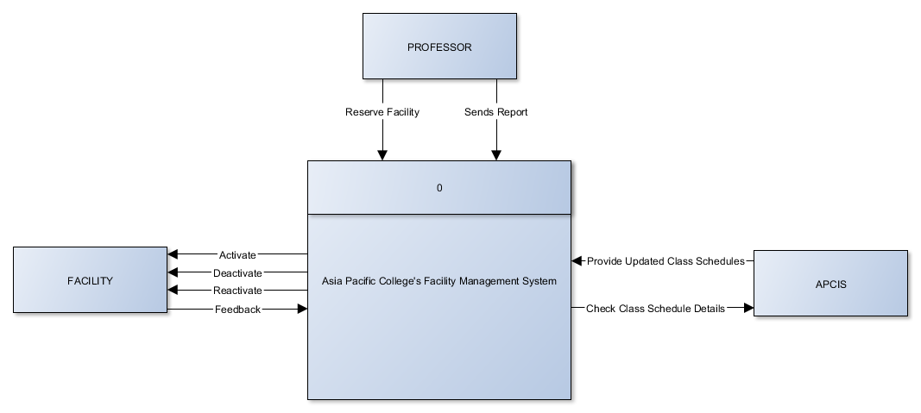

### Data Flow Diagram – Level 0

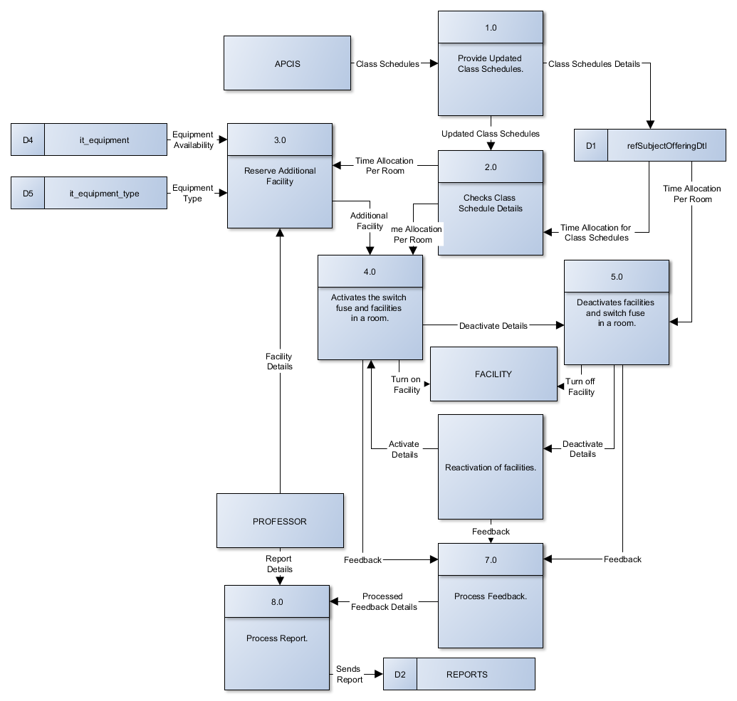

### Data Flow Diagram – Level 1

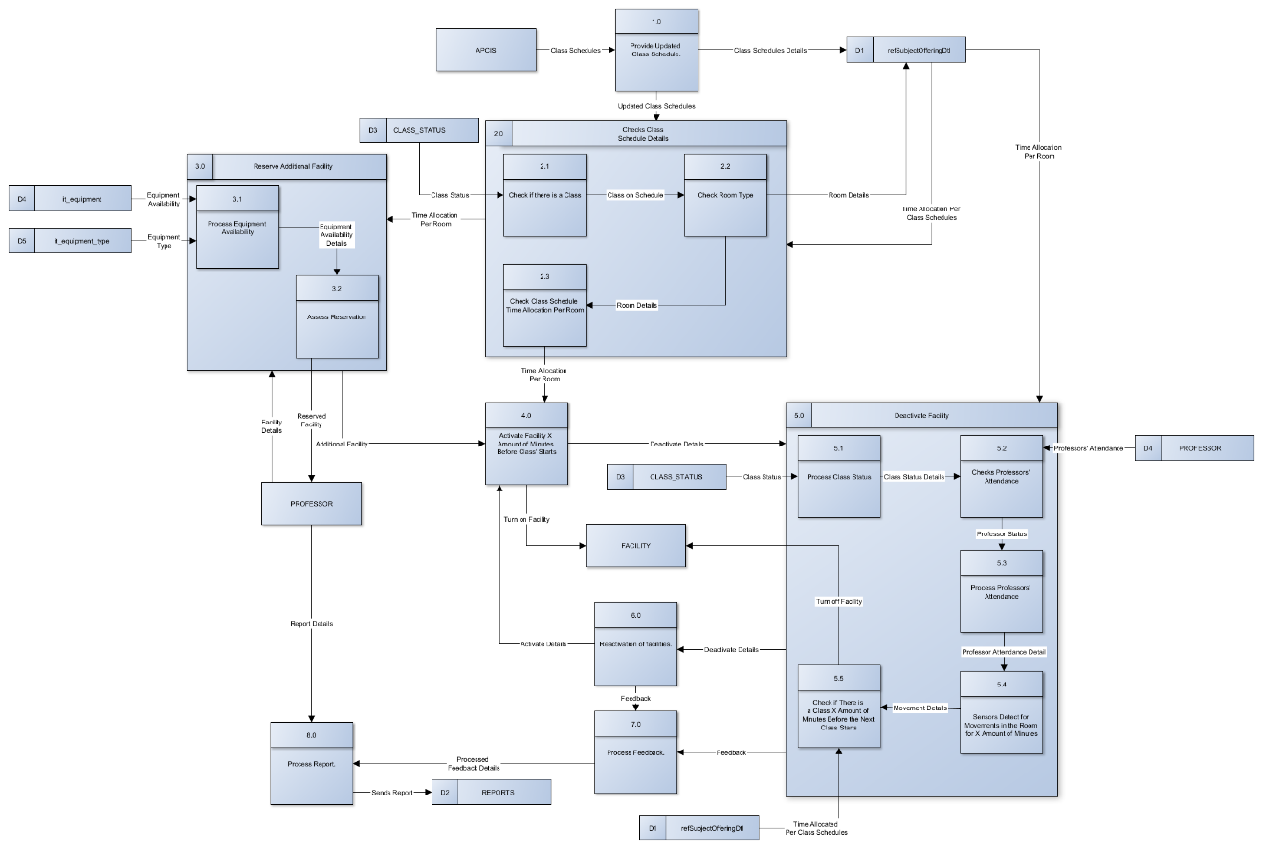

### Object Diagram

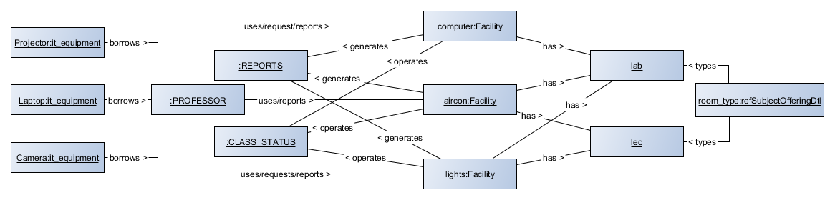

### Activity Diagram

### Use Case

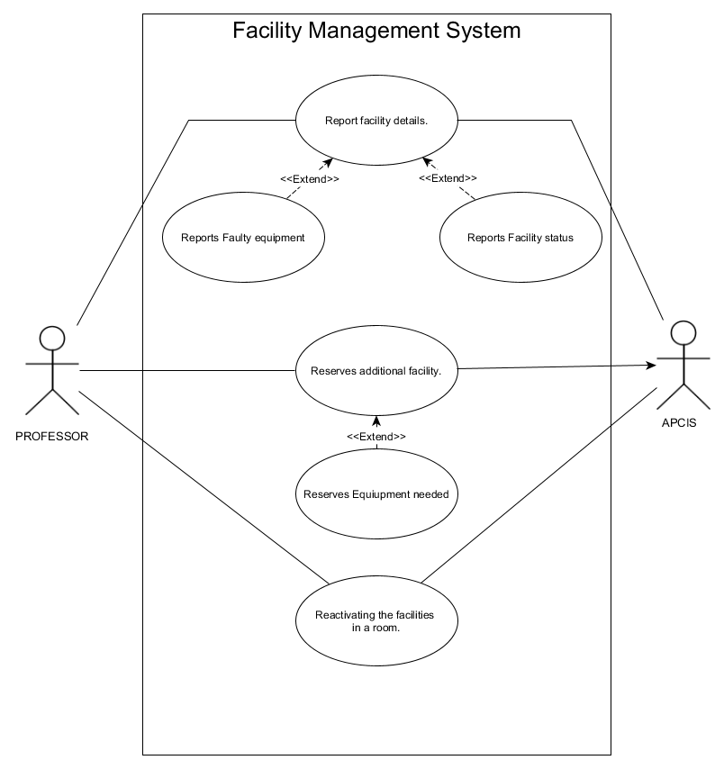

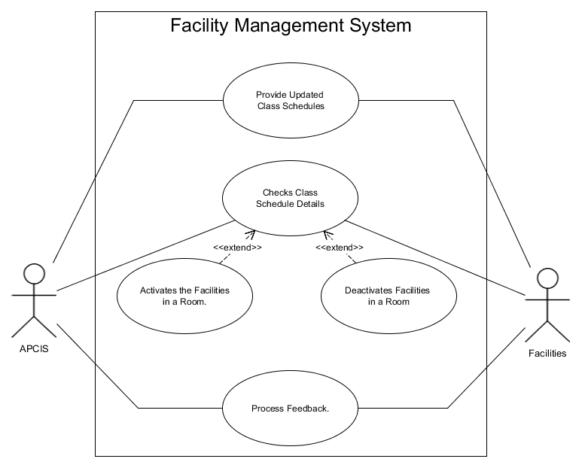

### Use Case Full Description

|  |  |  |
| --- | --- | --- |
| Use Case Name: | Provide Updated Class Schedules. | |
| Scenario: | Provide Class Schedules. | |
| Triggering Event: | Start of a New Term. | |
| Brief Description: | To provide the updated class schedules resulting from merging, dissolution and petitioned courses and latest courses for the new term. | |
| Actors: | FACILITY and APCIS. | |
| Related Use Case: | * Checks Class Schedule Details | |
| Stakeholders: | Registrar. | |
| Preconditions: | A new term has started and/or the merging, dissolution and petitioned are consummated. | |
| Post Conditions: | System is provided with the latest and/or updated set of class schedules. | |
| Assumptions: | Class schedule provided is for the current term. | |
| Flow of Activities: | Registrar | APCIS |
| 1.0 Deploys new sets of class schedules | 2.0 Stores new sets of class schedules |
| Exception Conditions: | * No new sets of class schedules. | |

|  |  |  |
| --- | --- | --- |
| Use Case Name: | Checks Class Schedule Details. | |
| Scenario: | Operation of Facilities. | |
| Triggering Event: | Class Schedules. | |
| Brief Description: | Facility Management System checks the class schedules stored in APCIS to operate the facilities. | |
| Actors: | FACILITY and APCIS. | |
| Related Use Case: | * Activates the facilities in a room * Deactivates facilities in a room * Process feedback | |
| Stakeholders: | ITRO. | |
| Preconditions: | A set of class schedules has been provided. | |
| Post Conditions: | System will operate the facilities based on the set of class schedules provided. | |
| Assumptions: | Class schedule provided is updated. | |
| Flow of Activities: | APCIS | Facility |
| 1.0 Provides sets of class schedules | 2.0Checks class schedule provided by APCIS |
| Exception Conditions: | * Suspension of classes. | |

|  |  |  |
| --- | --- | --- |
| Use Case Name: | Reserve additional facility. | |
| Scenario: | Professor reserves an additional facility | |
| Triggering Event: | Professor reserved additional facility. | |
| Brief Description: | Professor request a new facility | |
| Actors: | PROFESSOR and APCIS. | |
| Related Use Case: | * Activates facilities in a room * Deactivates facilities in a room * Checks Class Schedule Detail | |
| Stakeholders: | PROFESSORS | |
| Preconditions: | Operation of facilities | |
| Post Conditions: | A new facility was provided. | |
| Assumptions: | * Additional facility was requested because the current on is broken | |
| Flow of Activities: | Professor | APCIS |
| 1.0 Professor reserved a new facility | 2.0 A new facility was provided |
| Exception Conditions: | * All the facilities in the room are working * Not in need of another facility | |

|  |  |  |
| --- | --- | --- |
| Use Case Name: | Activates the switch fuse and facilities in a room. | |
| Scenario: | Activation of the facilities. | |
| Triggering Event: | Based on Class Schedules. | |
| Brief Description: | Activates the switch fuse for air conditioner and air conditioner itself 15 minutes before the time allocated and switch fuse for other facilities is turned on based on the time allocated. | |
| Actors: | FACILITY and APCIS. | |
| Related Use Case: | * Checks Class Schedule Details * Deactivates facilities in a room * Process feedback | |
| Stakeholders: | ITRO. | |
| Preconditions: | On the current time and given timeslot, there is a class. | |
| Post Conditions: | Lights, air condition and/or computers are activated. | |
| Assumptions: | There is a class on the current timeslot. | |
| Flow of Activities: | APCIS | Facility |
| 1. Provides sets of class schedules | 1. Checks class schedule provided by APCIS |
| Exception Conditions: | * No classes for the given timeslot * Suspension of classes | |

|  |  |  |
| --- | --- | --- |
| Use Case Name: | Deactivates facilities and switch fuse in a room. | |
| Scenario: | Deactivates the air conditioner, lights and/or computers and switch fuse. | |
| Triggering Event: | Turning off Facilities if:   * Professor is absent * Class is dismissed * Early dismissal * Class suspension | |
| Brief Description: | Deactivates the facilities in a room based on the class schedule provided by APCIS. | |
| Actors: | FACILITY and APCIS. | |
| Related Use Case: | * Checks Class Schedule Details * Activates facilities in a room * Process feedback | |
| Stakeholders: | Registrar and ITRO. | |
| Preconditions: | After the 5 number of minutes that the sensors had not detected any movement in a room. | |
| Post Conditions: | Lights, air condition and/or computers are deactivated. | |
| Assumptions: | * Professor is absent * Class is dismissed * Early dismissal * Class suspension | |
| Flow of Activities: | APCIS | Facility |
| 1.0 Provides sets of class schedules | 2.0 Checks class schedule provided by APCIS and other preconditions |
| Exception Conditions: | * Class is ongoing * Professor is present for the current timeslot * No suspension of classes | |

|  |  |  |
| --- | --- | --- |
| Use Case Name: | Reactivation of facilities. | |
| Scenario: | Reactivating the facilities in a room. | |
| Triggering Event: | Professor is late or the people using the room had to go out for more than 5 minutes. | |
| Brief Description: | Reactivates the switch fuse for all the facilities used in the room and facilities. | |
| Actors: | FACILITY and APCIS. | |
| Related Use Case: | * Checks Class Schedule Details * Activates facilities in a room * Deactivates facilities in a room | |
| Stakeholders: | ITRO. | |
| Preconditions: | Operation of Facilities. | |
| Post Conditions: | Process feedback provided by the facilities. | |
| Assumptions: | Facility was either turned on or off. | |
| Flow of Activities: | APCIS | Facility |
| 1.0 Provides sets of class schedules | 2.0 Provides feedback base on its operation |
| Exception Conditions: | * No suspension of classes | |

|  |  |  |
| --- | --- | --- |
| Use Case Name: | Process Feedback. | |
| Scenario: | Facility Sends Feedback. | |
| Triggering Event: | The time facilities are turned on and/or off. | |
| Brief Description: | System provides feedback base on the behavior of the facility. | |
| Actors: | FACILITY and APCIS. | |
| Related Use Case: | * Checks Class Schedule Details * Activates facilities in a room * Deactivates facilities in a room | |
| Stakeholders: | ITRO. | |
| Preconditions: | Operation of Facilities. | |
| Post Conditions: | Process feedback provided by the facilities. | |
| Assumptions: | Facility was either turned on or off. | |
| Flow of Activities: | APCIS | Facility |
| 1.0 Provides sets of class schedules | 2.0 Provides feedback base on its operation |
| Exception Conditions: | * No suspension of classes | |

|  |  |  |
| --- | --- | --- |
| Use Case Name: | Process Report | |
| Scenario: | Both professor reports and processed feedback are consolidated. | |
| Triggering Event: | Received professor reported state of facility and/or feedback from facility. | |
| Brief Description: | Professor reports about the state of the facility and is processed together with the facilities’ feedback. | |
| Actors: | PROFESSOR and APCIS. | |
| Related Use Case: | * Process Feedback * Activates facilities in a room * Deactivates facilities in a room | |
| Stakeholders: | PROFESSORS and ITRO. | |
| Preconditions: | Operation of facilities. | |
| Post Conditions: | Feedback and report if any, is processed | |
| Assumptions: | * Facility is operating * A faulty facility in a room | |
| Flow of Activities: | Professor | APCIS |
| 1. Uses facility 2. Reports faulty facility, if any | 3.0 Assess the report |
| Exception Conditions: | * No suspension of classes | |

### Entity Relationship Diagram

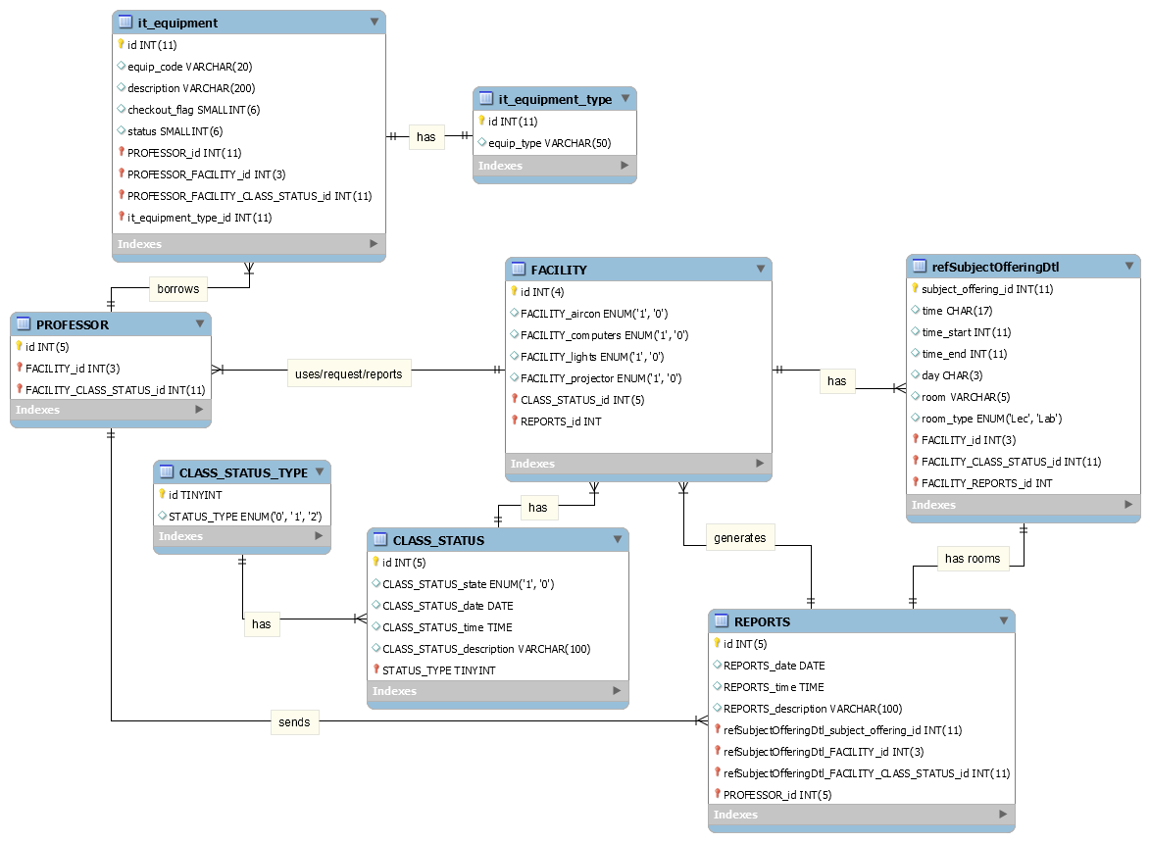

### Data Dictionary

## it_equipment

|  |  |  |  |  |  |  |  |
| --- | --- | --- | --- | --- | --- | --- | --- |
| Attribute Name | Contents | Type | Format | Range | Required | PK or FK | FK Referenced Table |
| Id | Unique identifier of it_equipment | Numeric(11) | 99999999999 | 0-99999999999 | Y | PK |  |
| equip_code | Code of equipment | VARCHAR(50) | Sample text here | 50 characters | Y |  |  |
| description | Remarks on reservation | TEXT | Sample text here | 65,535 characters | Y |  |  |
| Checkout_flag |  | SMALLINT(6) |  |  | Y |  |  |
| status | Status of reservation | Numeric(3) |  |  | Y |  |  |
| PROFESSOR_id | Unique identifier of  PROFESSOR | Numeric(11) | 99999999999 | 0-99999999999 | Y | FK | PROFESSOR |
| PROFESSOR_ FACILITY_id | Unique identifier of PROFESSOR | Numeric(3) | 999 | 0-999 | Y | FK | PROFESSOR |
| PROFESSOR_ FACILITY_ CLASS_ STATUS_id | Unique identifier of PROFESSOR | Numeric(11) | 99999999999 | 0-99999999999 | Y | FK | PROFESSOR |
| it_equipment_ type_id | Unique identifier of it_equipment_  type | Numeric(11) | 99999999999 | 0-99999999999 | Y | FK | It_equipment_ type |

## it_equipment_type

|  |  |  |  |  |  |  |  |
| --- | --- | --- | --- | --- | --- | --- | --- |
| Attribute Name | Contents | Type | Format | Range | Required | PK or FK | FK Referenced Table |
| id | Unique identifier of it_equipment_  type | Numeric(1) | 99999999999 | 0-99999999999 | Y | PK |  |
| equip_type | Type of equipment | VARCHAR(50) | Sample text here. | 50 Characters | Y |  |  |

## PROFESSOR

|  |  |  |  |  |  |  |  |
| --- | --- | --- | --- | --- | --- | --- | --- |
| Attribute Name | Contents | Type | Format | Range | Required | PK or FK | FK Referenced Table |
| id | Unique identifier of PROFESSOR. | NUMERIC(11) | 99999999999 | 0-99999999999 | Y | PK |  |
| FACILITY_id | Unique identifier of FACILITY. | Numeric(3) | 999 | 0-999 | Y | FK | FACILITY |
| FACILITY_ CLASS_ STATUS_ id | Unique identifier of CLASS_ STATUS | Numeric(11) | 99999999999 | 0-99999999999 | Y | FK | FACILITY |

## refSubjectOfferingDtl

|  |  |  |  |  |  |  |  |
| --- | --- | --- | --- | --- | --- | --- | --- |
| Attribute Name | Contents | Type | Format | Range | Required | PK or FK | FK Referenced Table |
| subject_offering_id | Unique identifier of refSubjectOfferingDtl. | NUMERIC(11) | 99999999999 | 1-99999999999 | Y | PK |  |
| time | To display the time format. | CHAR(17) | Sample text here. | 17 Characters. | N |  |  |
| time_start | Starting time of regular class schedule of the course. | NUMERIC(11) | 99999999999 | 1-99999999999 | Y |  |  |
| time_end | Ending time of regular class schedule of the course. | NUMERIC(11) | 99999999999 | 1-99999999999 | Y |  |  |
| day | Day/s of the week the course takes place. | NUMERIC(11) | 99999999999 | 1-99999999999 | N |  |  |
| room | Location of the room. | VARCHAR(5) | Sample text here. | 5 Characters. | Y |  |  |
| room_type | Type of the room, either lecture or laboratory. | ENUM | 'Lec', 'Lab' | 2 Constraints. | Y |  |  |

## FACILITY

|  |  |  |  |  |  |  |  |
| --- | --- | --- | --- | --- | --- | --- | --- |
| Attribute Name | Contents | Type | Format | Range | Required | PK or FK | FK Referenced Table |
| id | Unique identifier of FACILITY | Numeric(4) | 9999 | 0-9999 | Y | PK |  |
| FACILITY_aircon | Turn on = 1, Turn off = 0 | ENUM | 0 or 1 | 1 Character | Y |  |  |
| FACILITY_computers | Turn on = 1, Turn off = 0 | ENUM | 0 or 1 | 1 Character | N |  |  |
| FACILITY_lights | Turn on = 1, Turn off = 0 | ENUM | 0 or 1 | 1 Character | Y |  |  |
| FACILITY_projector | Turn on = 1, Turn off = 0 | ENUM | 0 or 1 | 1 Character | Y |  |  |
| CLASS_STATUS_id | Unique indentifier of CLASS_  STATUS_  id | Numeric(5) | 99999 | 0-99999 | Y | FK | CLASS_  STATUS |
| REPORTS_id | Unique identifier of REPORTS | Numeric(5) | 99999 | 0-99999 | Y | FK | REPORTS |

## CLASS_STATUS

|  |  |  |  |  |  |  |  |
| --- | --- | --- | --- | --- | --- | --- | --- |
| Attribute Name | Contents | Type | Format | Range | Required | PK or FK | FK Referenced Table |
| id | Unique identifier of CLASS_STATUS | Numeric(5) | 99999 | 0-99999 | Y | PK |  |
| CLASS_ STATUS_date | Date of class status. | DATE | ‘YYYY-MM-DD’ | '1000-01-01' to '9999-12-31' | Y |  |  |
| CLASS_ STATUS_time | Time of suspension. | TIME | ‘HH:MM:SS’ | ‘00:00:00’ to ‘23:59:59' | N |  |  |
| CLASS_ STATUS_  description | Description of suspension. | VARCHAR  (100) | Sample text here. | 100 Characters | N |  |  |
| STATUS_ TYPE | Unique identifier of CLASS_STATUS _TYPE | TINYINT | 128 | -127-128 | Y | FK | CLASS_  STATUS_ TYPE |

## CLASS_STATUS_TYPE

|  |  |  |  |  |  |  |  |
| --- | --- | --- | --- | --- | --- | --- | --- |
| Attribute Name | Contents | Type | Format | Range | Required | PK or FK | FK Referenced Table |
| id | Unique identifier of CLASS_STATUS _TYPE | TINYINT | 128 | -127-128 | Y | PK |  |
| STATUS_TYPE | Status of classes, whether there is a class or none. | ENUM | 0 or 1 or 2 | 1 Character | Y |  |  |

## REPORTS

|  |  |  |  |  |  |  |  |
| --- | --- | --- | --- | --- | --- | --- | --- |
| Attribute Name | Contents | Type | Format | Range | Required | PK or FK | FK Referenced Table |
| id | Unique identifier of REPORTS. | Numeric(5) | 99999 | 0-99999 | Y | PK |  |
| REPORTS_date | Date of report. | DATE | ‘YYYY-MM-DD’ | '1000-01-01' to '9999-12-31' | Y |  |  |
| REPORTS_time | Time of report. | TIME | ‘HH:MM:SS’ | ‘00:00:00’ to ‘23:59:59' | Y |  |  |
| REPORTS_description | Description of report. | VARCHAR(100) | Sample text here. | 100 Characters. | Y |  |  |
| refSubjectOfferingDtl_subject_offering_id | Unique identifier of refSubjectOfferingDtl. | NUMERIC(11) | 99999999999 | 0-99999999999 | Y | FK | refSubjectOffering_id |
| refSubjectOfferingDtl_FACILITY_CLASS_STATUS_id | Unique identifier of CLASS_STATUS. | NUMERIC(11) | 99999999999 | 0-99999999999 | Y | FK | FACILITY |
| PROFESSOR_id | Unique identifier of PROFESSOR. | NUMERIC(11) | 99999999999 | 0-99999999999 | Y | FK | PROFESSOR |
| PROFESSOR_FACILITY_id | Unique identifier of FACILITY. | NUMERIC(3) | 999 | 0-999 | Y | FK | PROFESSOR |

### Class Diagram

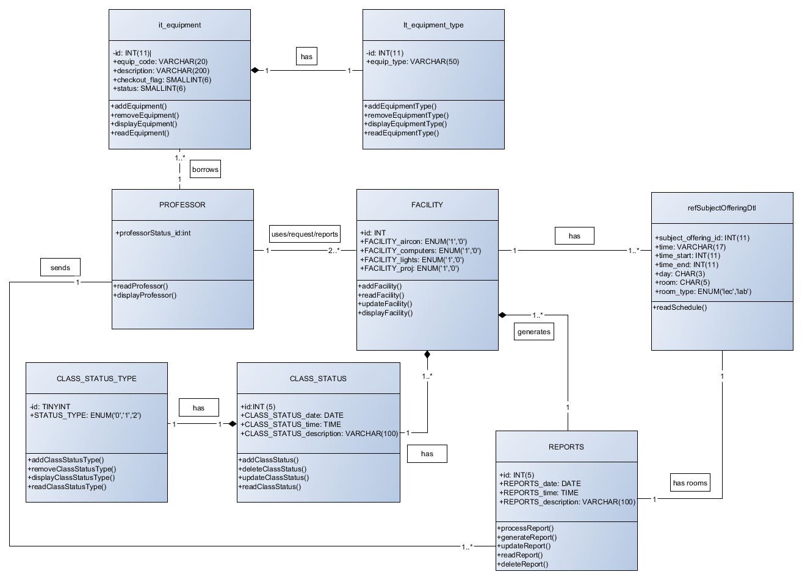

### System Sequence Diagram

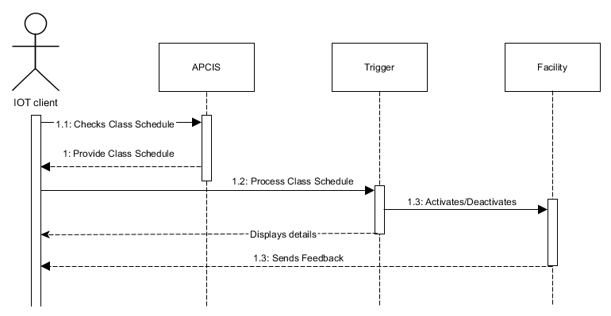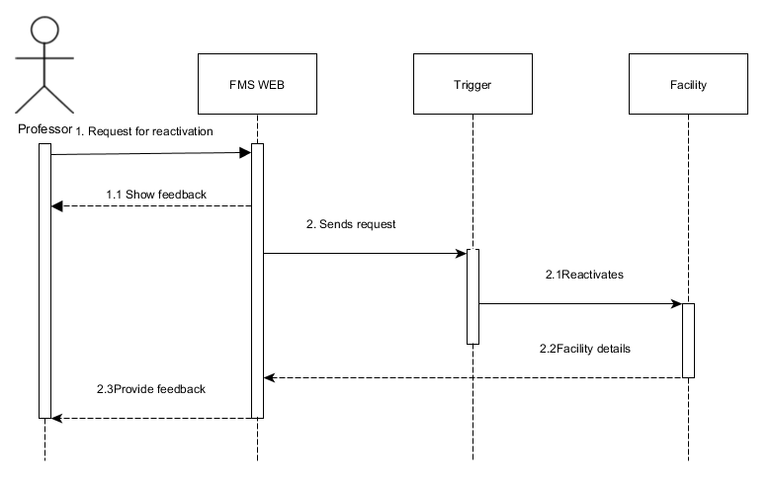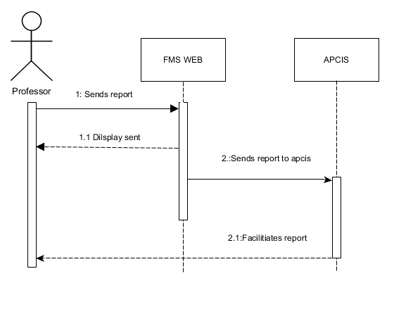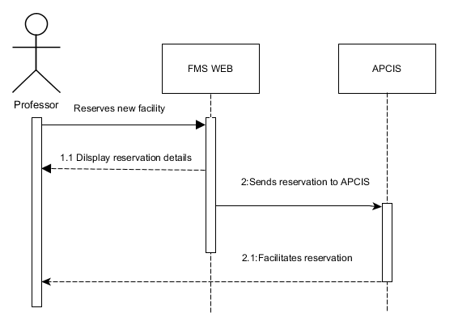

### Wireframe

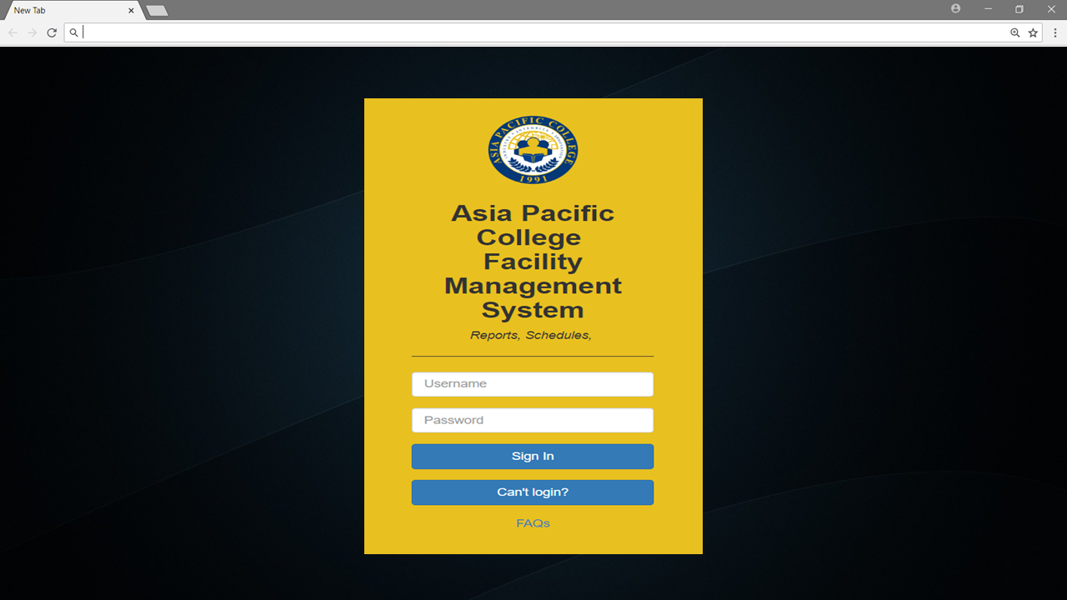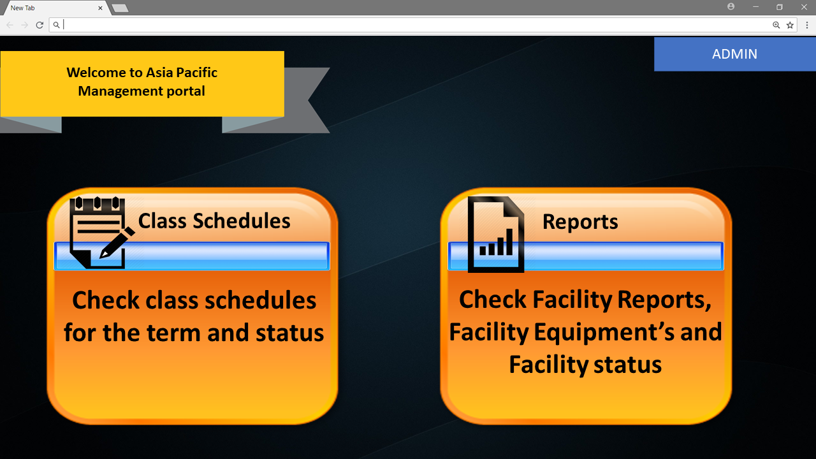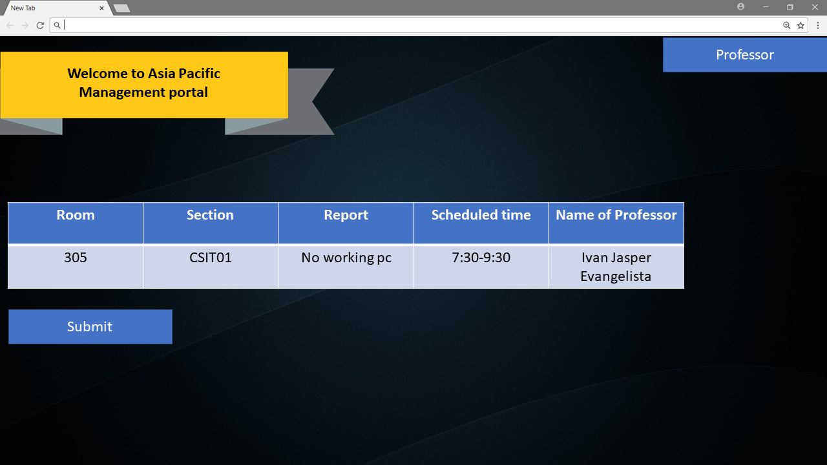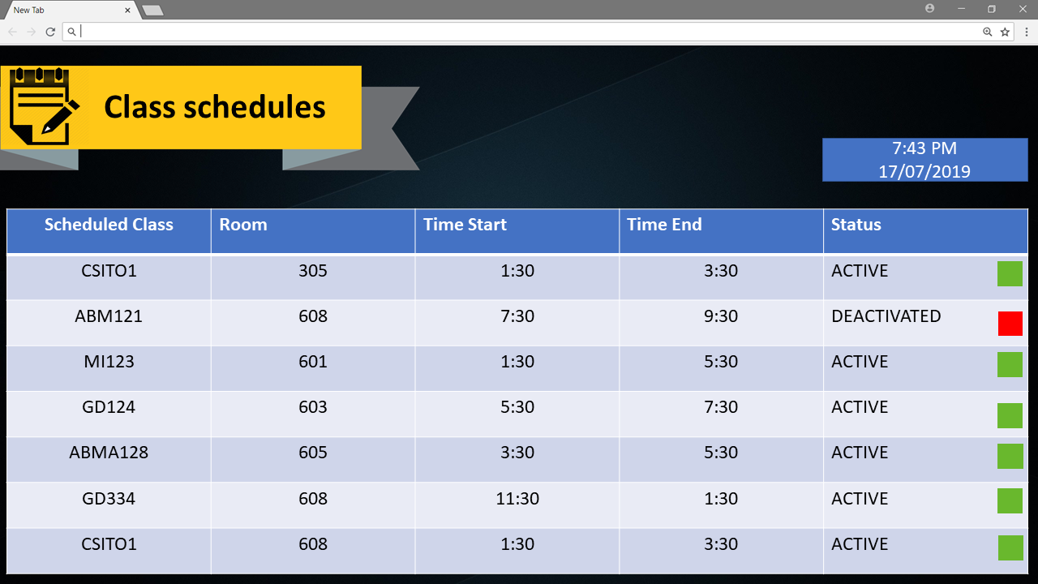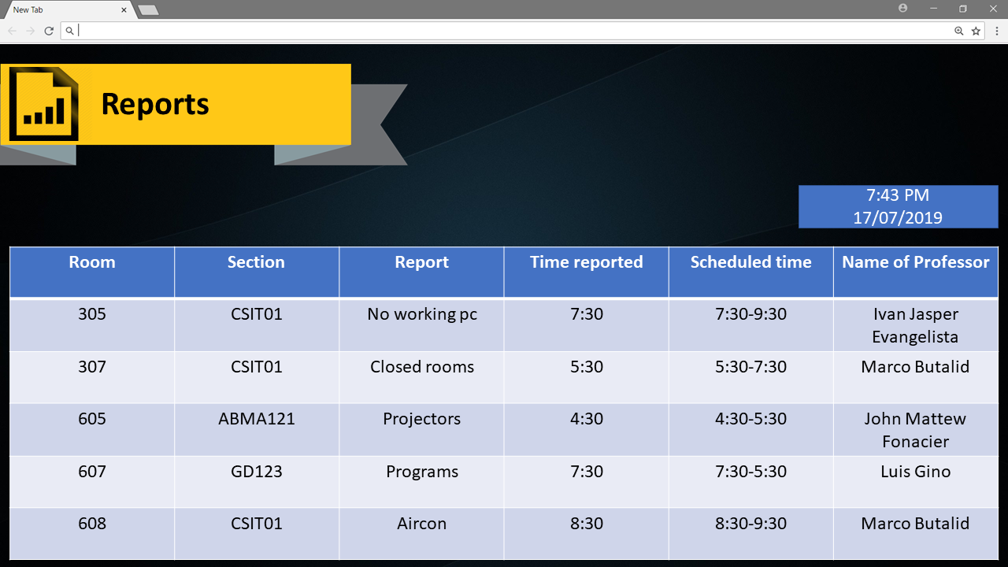

## Project Status Report Sections Omitted

